**Question1. Create a function that takes three arguments a, b, c and returns the sum of the numbers that are evenly divided by c from the range a, b inclusive.**

**Examples**

**evenly_divisible(1, 10, 20) ➞ 0**

**# No number between 1 and 10 can be evenly divided by 20.**

**evenly_divisible(1, 10, 2) ➞ 30**

**# 2 + 4 + 6 + 8 + 10 = 30**

**evenly_divisible(1, 10, 3) ➞ 18**

**# 3 + 6 + 9 = 18**

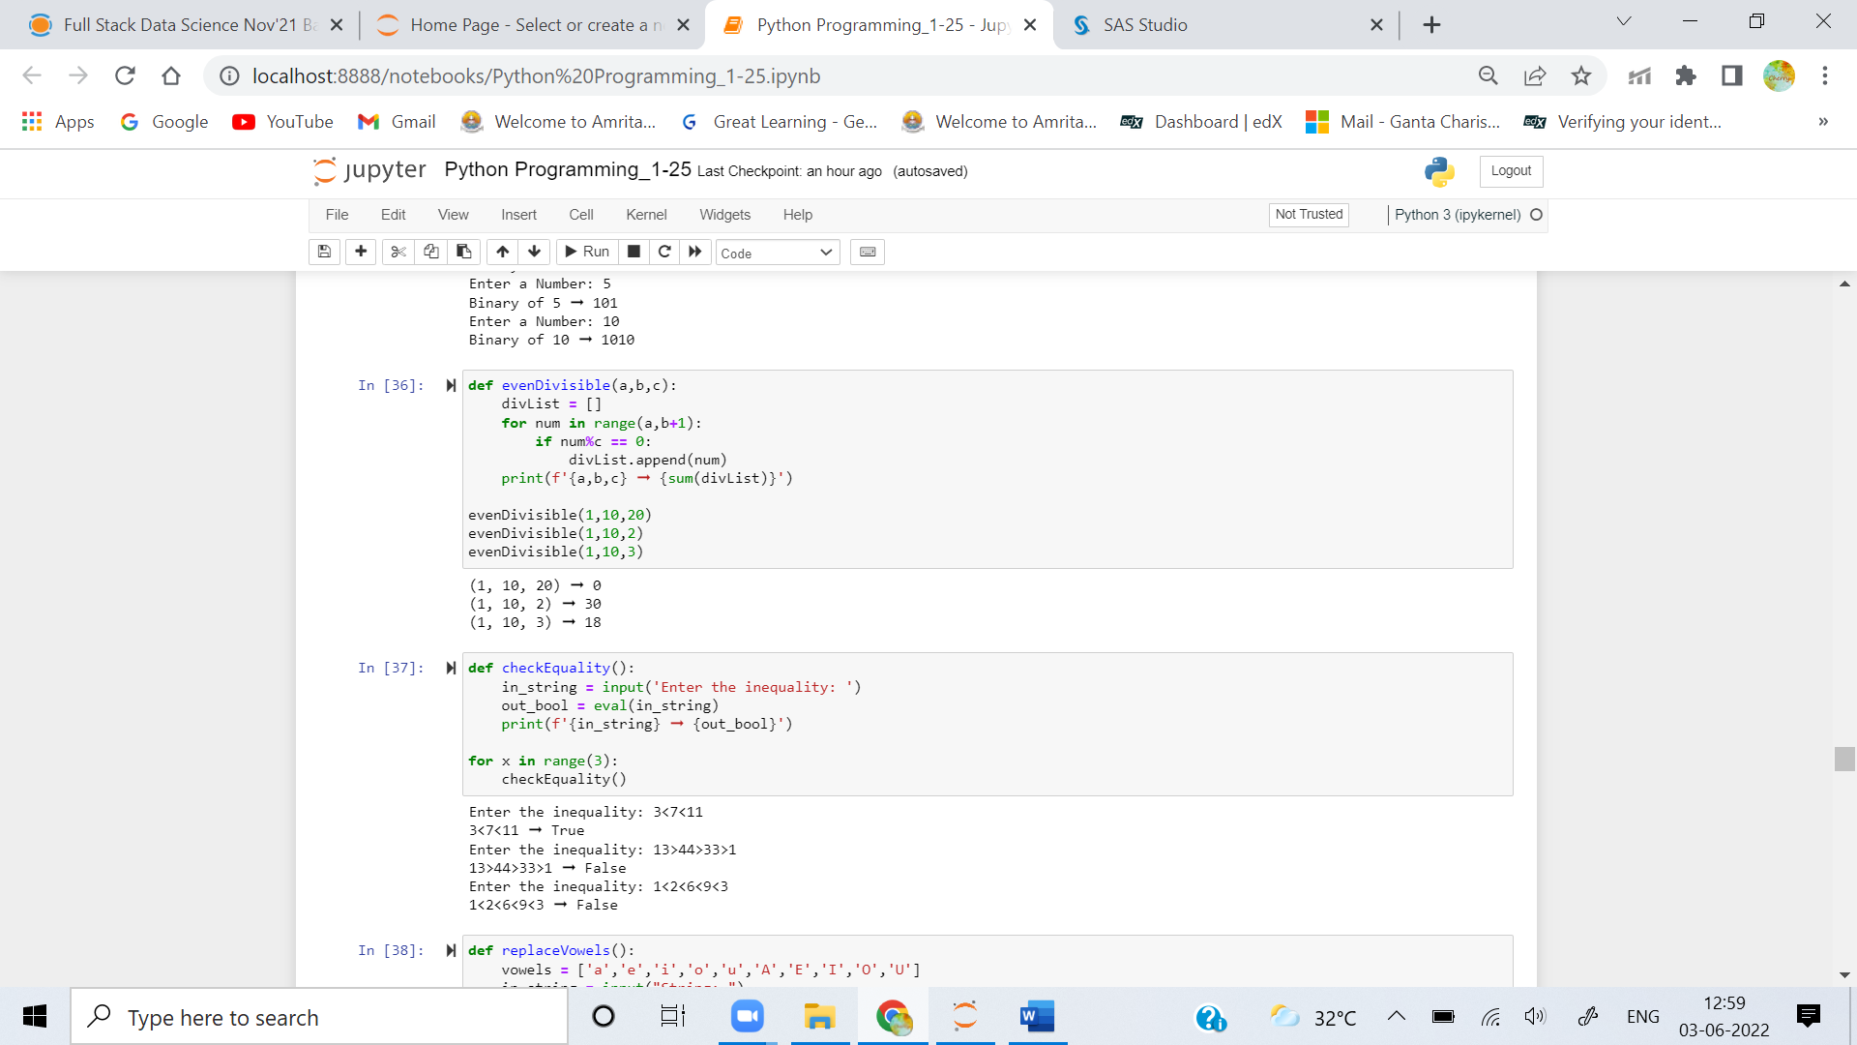

**Question2. Create a function that returns True if a given inequality expression is correct and False otherwise.**

### Examples

**correct_signs("3 < 7 < 11") ➞ True**

**correct_signs("13 > 44 > 33 > 1") ➞ False**

**correct_signs("1 < 2 < 6 < 9 > 3") ➞ True**



**Question3. Create a function that replaces all the vowels in a string with a specified character.**

### Examples

**replace_vowels("the aardvark", "#") ➞ "th# ##rdv#rk"**

**replace_vowels("minnie mouse", "?") ➞ "m?nn?? m??s?"**

**replace_vowels("shakespeare", "*") ➞ "sh*k*sp**r*"**

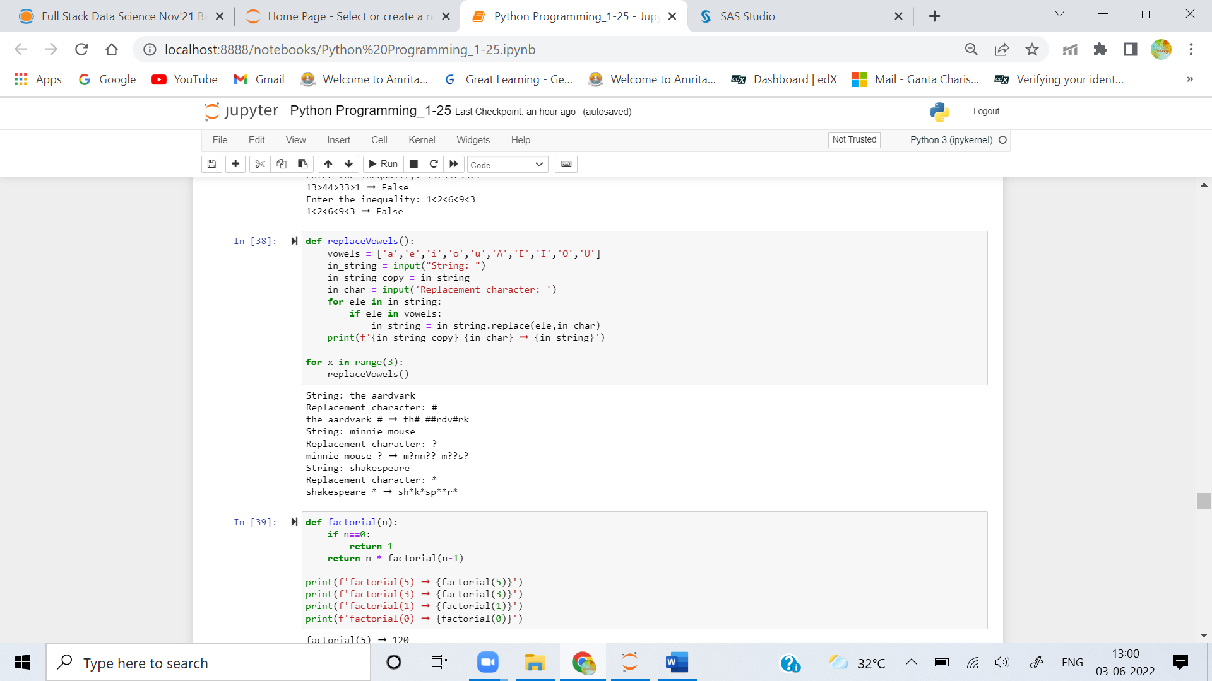

**Question4. Write a function that calculates the factorial of a number recursively.**

### Examples

**factorial(5) ➞ 120**

**factorial(3) ➞ 6**

**factorial(1) ➞ 1**

**factorial(0) ➞ 1**

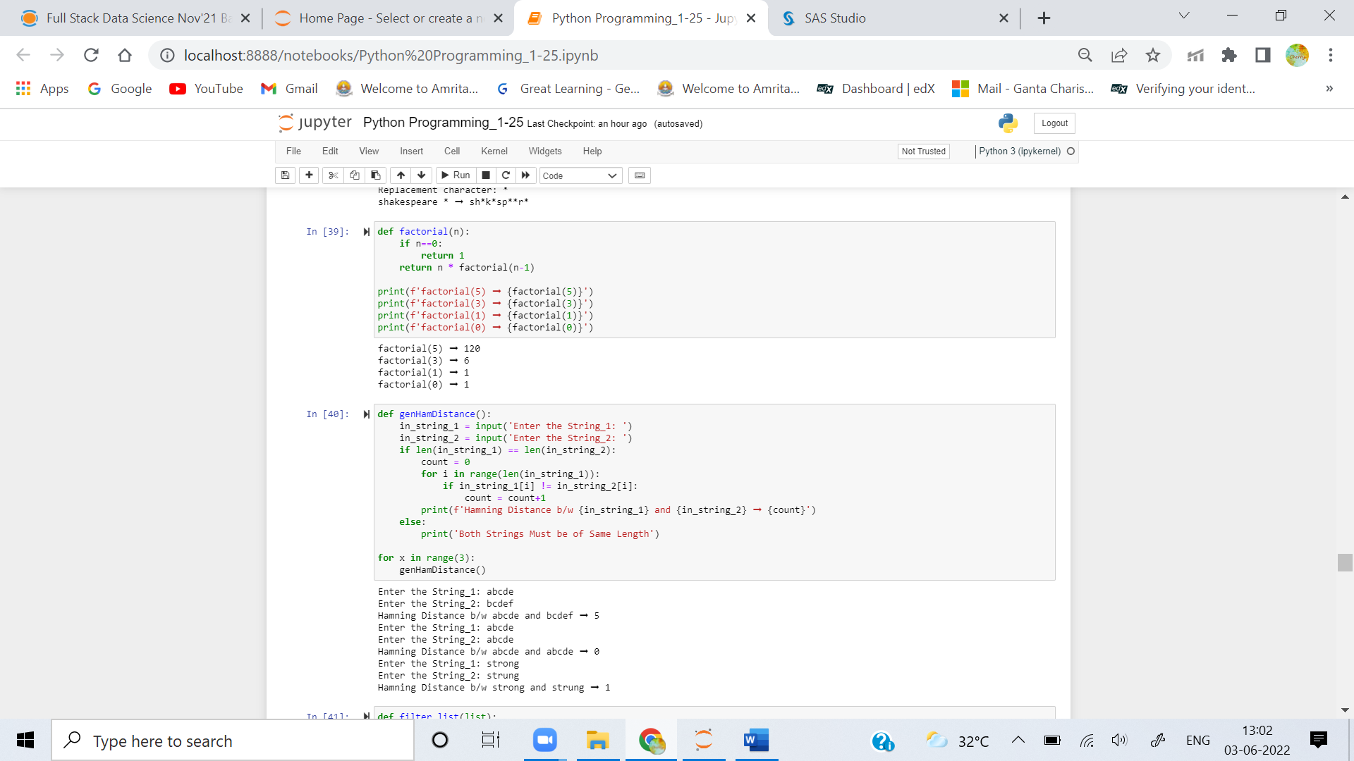

**Question 5**

**Hamming distance is the number of characters that differ between two strings.**

**To illustrate:**

**String1: "abcbba"**

**String2: "abcbda"**

**Hamming Distance: 1 - "b" vs. "d" is the only difference.**

**Create a function that computes the hamming distance between two strings.**

### Examples

**hamming_distance("abcde", "bcdef") ➞ 5**

**hamming_distance("abcde", "abcde") ➞ 0**

**hamming_distance("strong", "strung") ➞ 1**

